Eight Trail students to graduate early
BY KEVIN MCCONLOGUE Press Examiner 2/10/2021

Eight Lackawanna Trail students who completed their coursework to graduate will be honored on Thursday, Feb. 25; it was announced at the Trail school board meeting Monday. “All of these students are entering the workforce, "Principal Mark Murphy said. “And most of them have already accepted full-time job offers. Trail is very proud offal of these students for their hard work.” The graduation ceremony will be for the graduates and their families only.
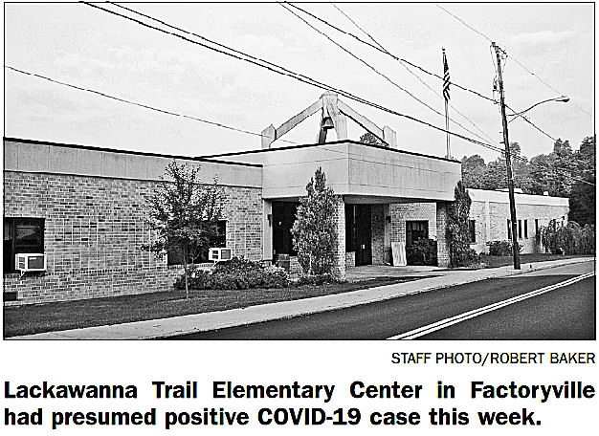
Superintendent Matthew Rakauskas also announced that there is a single presumed positive COVID-19 case at the elementary center. The Factoryville school will remain open as contact tracing has been performed, Rakauskas said, and the student and his teacher are currently self-isolating. He added, if there is a need to pivot to virtual learning, students and parents will be given advanced notice.

Rakauskas also addressed the status of when Trail faculty and staff will have access to a COVID-19 vaccine. He said no timetable has been established as to when a clinic will occur for faculty, but he hopes that it will be soon. “The district is on a waiting list with several different health organizations for when enough doses are available,” Rakauskas said. “Some of our Phase 1A employees have gotten their shots already, and we’re hoping to get everyone who wants the vaccine the opportunity to get it soon.”

Murphy also announced that each student athlete will be allowed two spectators at home sporting events for the rest of the winter sports season. This includes boys and girls basketball and wrestling.
Rakauskas also gave a presentation on the new and improved school district website. He said that the website is mostly completely updated, besides the teacher WebPages. The teacher pages will be updated in March, but parents can still have access to their child’s teacher by calling the school or by email. The district also recently created a new Facebook page with the goal of being able to get out information quicker, and having another form of communication. “Facebook is going to be a great way to get out information like two hour delays and virtual snow days to the community quickly,” Rakauskas said. “Along with the Remind app and the website, we have more than enough forms of communication.”

In other business, the board, in its virtual meeting, approved,
■ The assignment of a $1.28 million fund balance for the following pur poses: $600,000 for future capital projects; $404,803 for future technology costs; and $250,000 for textbook and curriculum costs.
■ A contribution of $14,897.79 to the Northeastern Educational Intermediate Unit for 2021-22.
■ The establishment of a school district federal funds bank account to hold any federal funds received in advance.
■ An e-rate funded network cabling project to add 50 cat6 cable drops district wide at a maximum cost of $10,000.
■ The sale of an electric kiln to Paul Debraski at a bid of $105. ■ The sale of a Hobart electric slicer to Paul Debraski at a bid of $101.
■ A contract with Lakeland School District to share transportation services to Western School for the Deaf.
■ A retirement memorandum of understanding for Patrice Gray at the end of the school year.
■ Appointed Tim Ronchi as a volunteer assistant track coach for the 2021 spring season.
The board will hold a work session on Monday, March 1, at 7:30 p.m. The Zoom link will be posted on the district website.

