Unapproved, unofficial, Minutes of the February 9, 2026 Lackawanna Trail School Board Meeting. These are personal observations and not comments on behalf of the Board or the School District. The LTSD Board of Education had a meeting @ 7:45pm in the PS Bank Auditorium with a watch/voice only ZOOM session, public notice having been given in accordance with Sunshine Act & LTSD Procedure #006. Board members present: Mrs. Clark, Mr. Dwyer, Mrs. Green, Mr. Johnson, Mrs. Litwin, Dr. Mould, Mr. Ross, Mr. Strauch, and Mrs. Wescott. Administrators present Mr. Rakauskas, Mr. Opalka, Mr. Glynn, Mr. Kearney Ms. Talarico, Mrs. Kuchak, and Mr. Buck.

There were two employees, two representatives of Murphy Dougherty & Co, one reporter and no police present at the meeting.

OLD AND UNFINISHED BUSINESS
Cheer proposal update
Banners in high school gymnasium
Google calendar for athletic facilities scheduling
Request to review audit
Standardized Test Scores Presentation - Shannon Kuchak
2024-2025 Audit Report Presentation - Murphy Dougherty & Co.

The following motions were approved by unanimous vote unless indicated otherwise.

0. Motion by Johnson, Clark that the minutes from the January 12, 2026 School Board Meeting and February 2, 2026 Work Session be approved as submitted.

1. Motion by Mould, Dwyer that all bills found to be true and accurate be approved.
Passed 8-0-1, Strauch abstained (attachment A)

2. Motion by Mould, Dwyer to approve the December Treasurer’s Report as submitted.

3. Motion by Johnson, Clark to acknowledge the resignation of Business Manager, Keith Glynn effective March 12, 2026.

4. Motion by Dwyer, Mould to appoint Keith Glynn as a consultant to the Business Office for a fee of $10,000 through June 30th 2026. Passed 8-0-1. Green abstained.

5. Motion by Dwyer, Johnson to appoint Emily Hickox as Business Manager at a first year prorated salary of $85,000 beginning on February 10, 2026. All clearances are on file.

6. Motion by Dwyer, Litwin to approve the 2024-25 audit and single audit report as performed and issued by Murphy Dougherty and Co. Passed 8-0-1. Strauch abstained (attachment B)

7. Motion by Clark, Dwyer to approve the budget for the Northeastern Educational Intermediate Unit #19 for the fiscal year July 1, 2026 to June 30, 2027. Lackawanna Trail’s estimated contribution is $14,922.48.

8. Motion by Dwyer, Strauch to nominate Jaclyn Litwin to represent Lackawanna Trail School District on the Intermediate Unit #19’s Board of Directors from July 1, 2026 to June 30, 2029.

9. Motion by Dwyer, Clark to approve the contract with GSL Government Consulting to work with the district to submit an application during the Public School Facility Improvement Grant application window as well as providing support for this award post-application process. They charge 13% if a successful grant is received.

10. Motion by Johnson, Mould to approve the resolution to request a Public School Facility Improvement grant through the Pennsylvania Department of Community and Economic Development and the Commonwealth Financing Authority. Approved 7-1-1. Strauch abstained (attachment C), Green voted ‘NO’. See conflict with the Public School Facility Improvement Grant Program Guidelines.

11. Motion by Dwyer, Mould to approve the master construction agreement with Trane for replacement of boilers and generator in the amount of $2,488,571.00 from assigned fund balance with procurement through Omnia Partners. Approved 8-1-0 Green voted ‘NO’.

12. Motion by Clark, Litwin to approve the second reading of the following policies:
002 Authority & Powers
105.2 Exemption From Instruction
122 Extracurricular Activities
122.1 Noncurriculum-Related, Nonschool-Sponsored, Student-Initiated Groups
610 Purchases Subject to Bid/Quotation
611 Purchases Budgeted
816 District Social Media
C. Motion by Clark, Dwyer to have items 13, 14, and 16-21 treated as consent agenda.

C13. Motion to approve the FBLA field trip to the FBLA State Conference in Hershey, PA from April 12-15, 2026 at a cost to the district of one substitute.

C14. Senior Class Trip
Motion to approve the senior class field trip to Pocono Valley in Stroudsburg, PA from May 21-22, 2026 at a cost to the district of substitutes.

15. Motion by Clark, Litwin to approve Ella Naylor as a part-time paraprofessional, 4¾ hours per day, as scheduled, at the rate of $16.00 per hour per the LTESPA collective bargaining agreement, effective February 10th, 2026. All clearances are on file.

C16. Motion to approve Korrie Higgins as a volunteer with Junior High Softball for the 2025-2026 school year. All clearances are on file.

C17. Motion to approve Jennifer Perry as a returning volunteer with Track & Field for the 2025-2026 school year. All clearances are on file.

C18. Motion to approve Jeff Stage as a returning volunteer with Track & Field for the 2025-2026 school year. All clearances are on file.

C19. Motion to approve Brian Kearney as a returning volunteer with Track & Field for the 2025-2026 school year. All clearances are on file.

C20. Motion to approve Candice Pagnotti as a returning volunteer with Track & Field for the 2025-2026 school year. All clearances are on file.

C21. Motion to approve Brendan Dwyer as a returning volunteer with Track & Field for the 2025-2026 school year. All clearances are on file.

ADJOURNMENT 9:39pm

There was an Executive Session before the meeting from 6:30-7:42 to discuss:
- Details of a Bookkeeper position
- Details of various coach positions
- Resources needed for the Junior High Cheer Club
- Details of the transition to a new Business Manager

An Executive Session was announced to be held before the next public meeting
on March 2, 2026

ATTACHMENT A
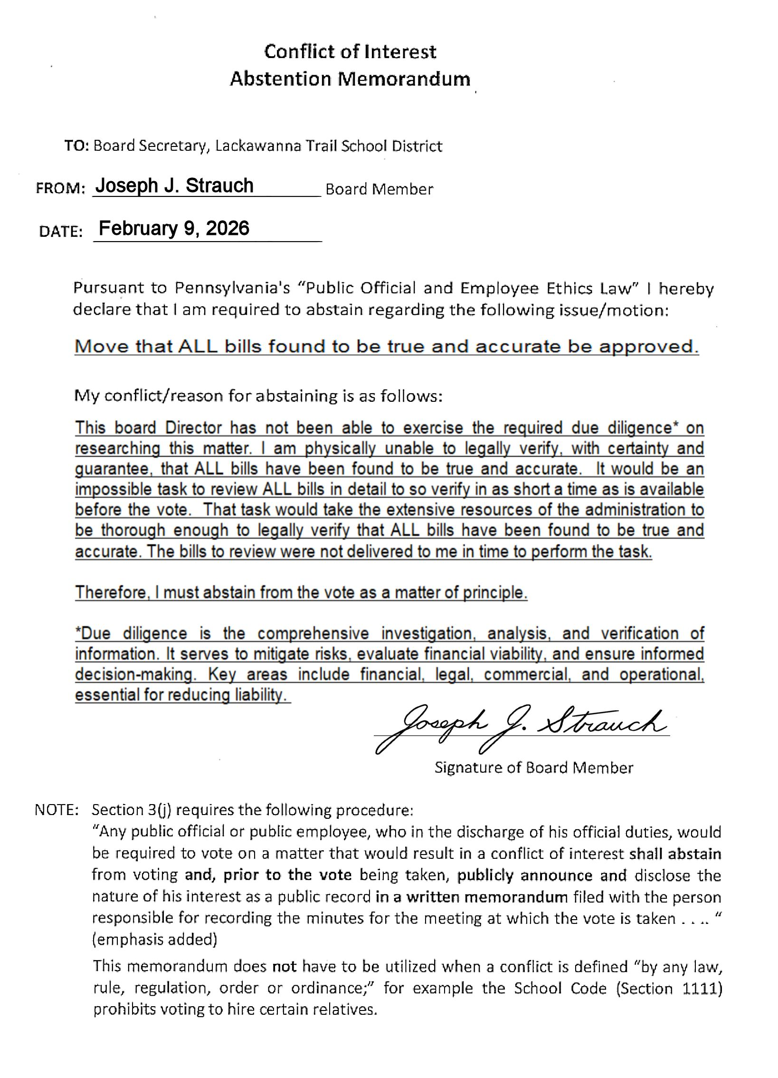

ATTACHMENT B

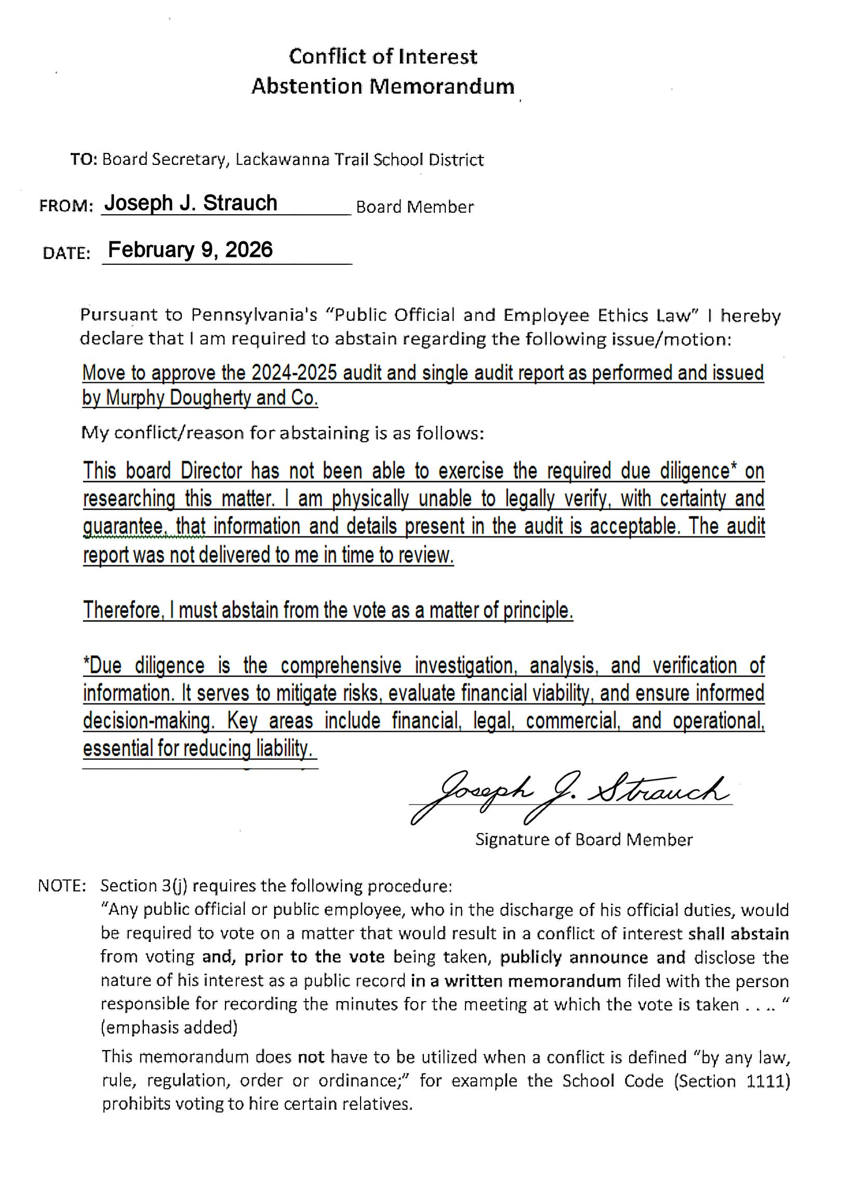

ATTACHMENT C

