Unapproved, unofficial Minutes of the November 11, 2019 Lackawanna Trail School Board Meeting
The LTSD Board of Education had a meeting on November 11, 2019 @ 7:30pm in the Board room, public notice having been given in accordance with Pa.C.S.A. § 709 (Sunshine Act) & LTSD Procedure #006. The President called the meeting to order. Present: Mr. Bianchi, Mr. Minick, Dr. Mould, Mr. Mulhern, Ms. Naylor, Mr. Ross, Mr. Strauch, Mr. Thorne. Absent: Mr. Stark. Administrators present: Mr. Rakauskas, Dr. Murphy, Mr. Kearney, Mr. Glynn, Ms. Talarico, Mr. Kordish, Ms. Crum.

There were eleven members of the public and one reporter present at the meeting.
There was a lengthy public discussion about the enforced one-bus position for student transportation.

All motions approved by unanimous approval unless indicated otherwise.

+ Motion by Mr Ross, Ms. Naylor to approve the minutes from the previous meetings. Approved 8-1, Mr. Strauch abstaining since he was at a PSBA event on the night of the meeting.

+ Motion by Mr. Thorne, Dr. Mould that all bills found to be true and accurate be approved.

+ Motion by Dr. Mould, Mr. Strauch to approve the Treasurer’s Report as submitted.

+ Motion by Mr. Ross, Mr. Bianchi to approve a private vehicle contract for Summit Christian Academy transportation for Wayne Burns at State Formula.
+ Motion by Ms. Naylor, Mr. Minick to approve the appointment of Lauren Gratz to the Elementary Special Education Teaching position beginning Tuesday, December 3, 2019, at Masters’ Level Step 1, $56,588 prorated, as stipulated in the collective bargaining agreement. All clearances are on file.
+ Motion by Ms. Naylor, Mr. Bianchi to approve the appointment of Erin Merkel as the mentor to the Elementary Special Education Teacher, Lauren Gratz, at a stipend of $450 prorated for the 2019-2020 School Year, as per the LTEA agreement.
+ Motion by Mr. Strauch, Mr. Minick to acknowledge the resignation of James Becchetti as the K-6 Physical Education Teacher, the Co-Athletic Director and the Equipment Manager effective December 20, 2019.
+ Motion by Mr. Ross, Mr. Strauch to approve Corinne Theil as a volunteer Jr. High Girls’ Basketball coach for the 2019-2020 year. All clearances are on file.
+ Motion by Mr. Minick, Dr. Mould to approve Ben Domiano as a volunteer Jr. High Boys’ Basketball coach for the 2019-2020 year. All clearances are on file.
+ Motion by Mr. Strauch, Dr. Mould to approve John Yanniello as a volunteer Jr. High Boys’ Basketball coach for the 2019-2020 year. All clearances are on file.
+ Motion by Mr. Ross, Ms. Naylor to approve Jeffery Marx as a volunteer Wrestling coach for the 2019-2020 year. All clearances are on file
+ Motion by Mr. Minick, Mr. Mulhern to approve Jonathan Lynn as a volunteer Jr. High School Wrestling coach for the 2019-2020 year. All clearances are on file.
+ Motion by Mr. Mulhern, Mr. Thorne to approve Chaz Ross as a volunteer Jr. High School Wrestling coach for the 2019-2020 year. All clearances are on file.
+ Move by Ms. Naylor, Mr. Ross that the Board acknowledge the resignation of Otylia Dugan as the Wrestling/Basketball Cheerleader Advisor.
+ Motion by Mr. Ross, Mr. Minick to approve Sarah Richard as the Wrestling/Basketball Cheerleader Advisor, starting 2019-2020 school year, at a stipend of $2550, per the LTEA collective bargaining agreement. All Clearances on file. Passed 7-1, Mr. Strauch voting "no".
+ Motion by Mr. Bianchi, Mr. Thorne to approve Kevin Dikeman’s request to take approximately 40 students from the High School Music Department on a field trip to Nashville, Tennessee, from June 14-18, 2020, at no cost to the school district. Passed 7-1, Mr. Strauch voting "no" because, although it was a great destination, he argued that the 15-hour and 12-hour bus rides to and from Tennessee were cruel and unusual punishment and contrary to the safety of the students.
Meeting adjourned 8:46pm.

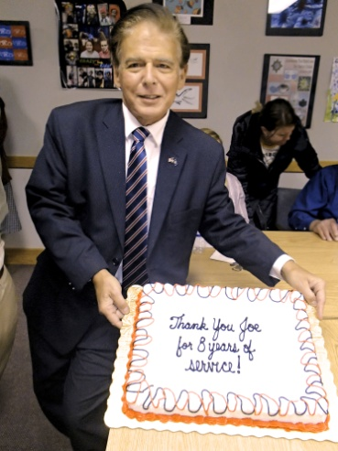
There was a cake presented to thank Mr. Strauch for his eight years of service.

---------------------------------------------------------------------------------------------------------------------------------------------------------------------
There was an Executive Session from 6:30 - 7:19pm

+ to discuss the necessary openings created by the resignation of Mr. Becchetti. There will be a publication of the details soon
+ to discuss staffing effects dependent on the Trail Cyber Academy.
+ to discuss Contract negotiations timelines
+ to discuss staff support of teacher conferences

An Executive Session is anticipated before the next meeting

